**Terraform Assignment - 1**

You have been asked to:

● Create an EC2 service in the default subnet in the ohio region

Create instance and install terraform

wget -O - https://apt.releases.hashicorp.com/gpg | sudo gpg --dearmor -o /usr/share/keyrings/hashicorp-archive-keyring.gpg

echo "deb [arch=$(dpkg --print-architecture) signed-by=/usr/share/keyrings/hashicorp-archive-keyring.gpg] https://apt.releases.hashicorp.com $(lsb_release -cs) main" | sudo tee /etc/apt/sources.list.d/hashicorp.list

sudo apt update && sudo apt install terraform

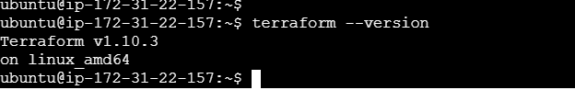

Create the main.tf file



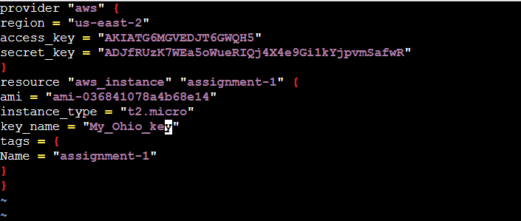

Terraform init

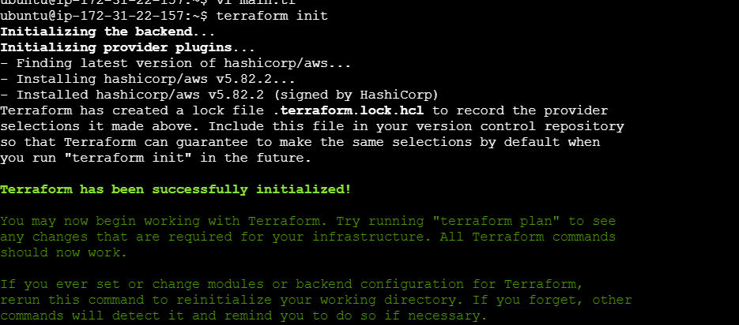

Terraform plan

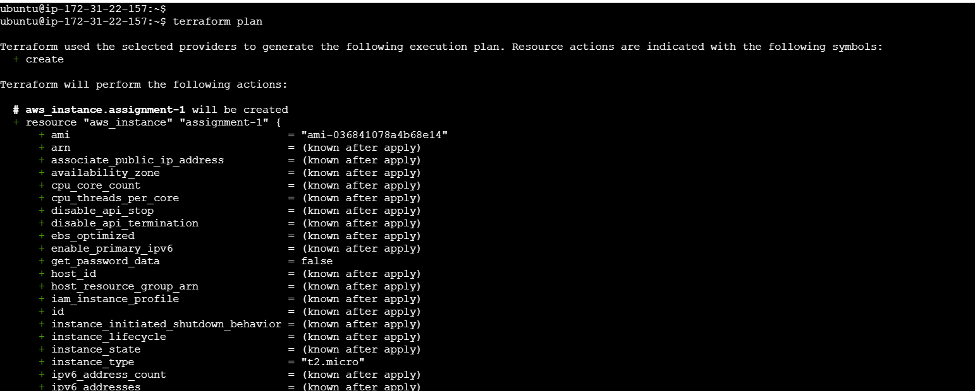

Terraform apply

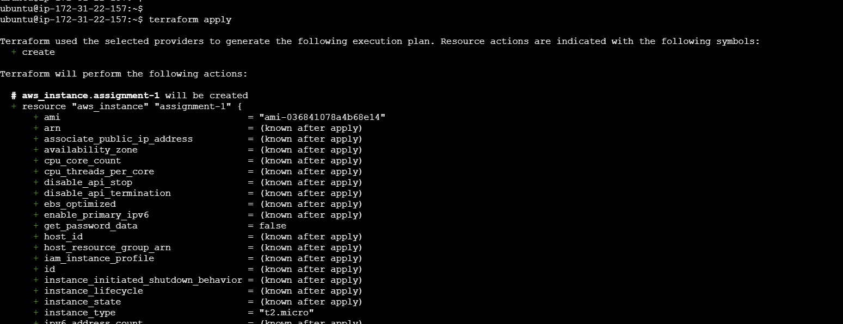

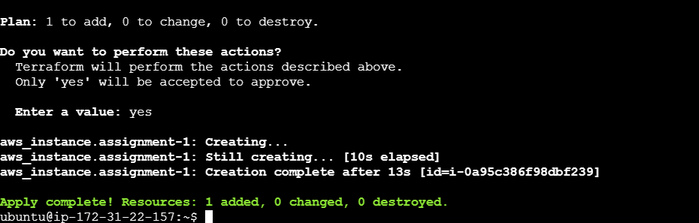

Instance created in Ohia region

